Fossil Preparation Volunteer Training Guide

by Justy Alicea
Introduction by Larry Rinehart and Mary Moore
2026 version

Fossil preparation volunteer training guide

Original Author: | Larry Rinehart and Mary Moore
Application: | MS Word
File Name: | ##### Paleo Prep Guide

REVISION HISTORY

Rev. | Revision Description | Approved By:
1.0 | Rinehart and Moore | Rinehart
2.0 | 2021 Revision by Justy Alicea | Justy Alicea
3.0 | 2022 Revision by Justy Alicea. Overhaul to meet OSHA standards; addition of updated Getty SOPs | Justy Alicea
4.0 | 2024 update | Justy Alicea
5.0 | 2025 update | Justy Alicea
6.0 | 2026 update using AI | Justy Alicea

I Introduction
II Scope
III Lab Comfort
IV Lab Safety
V Overview of Lab Processes
5.1 Laboratory Work
5.2 Excavating and Collecting
5.3 Archival Cradling
VI Standard Operating Procedures
6.1 Manual Preparation
6.2 Air-Scribe
6.3 Air-Abrasive
6.4 PVA
6.5 Reaction Adhesives
6.6 Jackets/Cradles
6.7 Cast-Cutters
6.8 Angle-Grinders
6.9 Molding
6.10 Casting

I
Introduction
From the late 1800’s through the 1970’s, many New Mexico fossils were excavated and shipped to far flung locations throughout the United States and the world. Many of these fossils can be seen when visiting major museums in the larger cities of this country. As a response to the removal of New Mexico fossils, residents of our state petitioned the legislature to fund the development of a natural history museum. Thus, the New Mexico Museum of Natural History (NMMNH) was born. Two of the Museum’s mandates were to focus on preservation of our state fossil resources and to serve as a fossil collection repository. The NMMNH opened its doors to the public in 1986 and has continued to evolve and grow in popularity. Later, the scope of the Museum was expanded and it was renamed the New Mexico Museum of Natural History and Science (NMMNHS) to reflect those developments.
The Paleontology Collections and Research group at the Museum currently includes Paleontology Curators,_____; _____, Geosciences Collections Manager; and _____, Chief Preparator and Paleontology Prep Lab Manager. All other fossil preparators are volunteers, and as such are members of the Volunteer Association which is organized by the Volunteer Coordinator, ______. Many volunteers are also members of Friends of Paleontology (FOP) and take part in its activities.

This guide is designed to be used as a reference for techniques and materials often used in preparation and excavation by NMMNHS paleontology personnel. It describes equipment, supplies, and techniques used in the laboratory and the field. The guide contains information on equipment which the volunteer might not have yet used, might not have been included in prep class instruction, or for which the volunteer needs a refresher or supportive information. Volunteers should contact the prep lab manager about any fossil preparation questions and concerns.

Larry Rinehart and Mary Moore

Fossil preparation questions should be directed to:
________, Lab Manager
###-###-#####
email

II
Scope
This Guide is meant to serve as an overview of the procedures and processes for the preparation of fossils. Included here are the Standard Operating Procedures (SOPs) of the Fossil Preparation Labs at the ###### for the purposes of compliance with OSHA standards. As such this should be kept together with the rest of the Lab Safety Binder manuals in the Lab Library.
Due to the scope of the various activities of the lab regarding chemical usage, processes, and waste generation, this document is not intended to be comprehensive. Instead, it is intended to provide a general overview in defining safe work practices. Some procedures described in this guide are restricted to staff only. Volunteers may perform only those tasks explicitly assigned. Refer to the Lab Safety Manual for required controls and restrictions.
III
General Lab Comfort

- Wear closed toe shoes. This rule, among others, has been the same for all labs since forever. Chemicals in the prep lab are not very dangerous, but they are chemicals you do not want on your skin none the less. There are also extremely heavy objects you do not want falling on your toes. This is not optional.
- Almost all paleontology work is dirty and dusty. Only wear clothes you are comfortable destroying.

IV
General Lab Safety
- Only use lab authorized Personal Protective Equipment (PPE). We cannot guarantee the efficiency of any other types of PPE.
- All lab members are responsible for their own respirators. All respirator use (including N95s) requires participation in the labs Respiratory Protection Plan.
- Wear a dust mask to avoid inhaling nuisance dust particles. Most of the rock we work on contains silica. Silica is fine sand dust. Silica dust acts like microscopic shards of glass. It can cause serious lung problems over time. Do not allow yourself to inhale silica.
- Dust masks do not protect against vapors or fine dust particulates. For these a half face fitted respirator must be used, at minumum. Consult the Standard Operating Procedures provided in this manual for all safety equipment requirements for specific procedures.
- Some type of adequate eye protection must be used when dust and debris are being generated. This is not optional.
- Ear protection is available in the form of foam ear plugs and ear muffs. Use them if you are generating a substantial amount of noise. Prolonged exposure to loud sounds can damage hearing.
- Nitrile gloves are available for use when handling chemicals
- Get up and take regular breaks to give eyes, hands and back a rest. Change positions often to avoid muscle strain. Preparation can easily lead to repetitive stress injuries in the hands, shoulders, and neck if working for prolonged periods of time.
- Hands or forearm ache? You may be holding the tool too tightly. Relax your grip and allow the tool to do the work with only minimal force exerted on it. Concentrate on guiding tools, not on applying force.
- For more in depth information, see Lab Safety Manual.

V
Overview of Lab Processes

- Laboratory Work

Overview of Lab Process
- Only authorized volunteers are allowed in the fossil labs. All unauthorized persons must be cleared with the lab manager in writing. See section 3.2 in the Lab Safety Manual for more information
- Volunteers work in one of two laboratories.
- Lab 1 -
- Lab 2 -
- Specimens are collected and stored in the fossil outbuilding.
- New projects are assigned by the lab manager when the lab manager deems a volunteer is ready.
- Volunteers must fill out a loan tag/label and a prep record form, as well as take photos of the specimen before beginning work on any fossil. It is very important that you keep these with the specimens at all times. It is very easy to lose track of specimens in numbered trays full of fossils.
- Specimens are prepared with oversight from prep lab manager and guidance from the supervising curator.
- Prep lab manager and curator approve completion of all projects.
- Any materials needed to safeguard the specimen during storage (ie conservation grade cradles) are manufactured.
- Finished project is taken to Collections Manager.
- Specimen is added to database and receives a catalog number.
- Specimen is readied for exhibit, display, or is kept in Collections for later use in exhibits and/or scientific research.

Equipment
- Main safety equipment provided - Dust masks, ear plugs, rubber (nitrile) gloves, safety glasses/goggles for eye protection, lab coats and aprons. See specific SOP for procedure and Lab Safety Manual for more information on proper use.
- Do not bring personal tools, equipment, chemicals etc into the lab.
- Lamps and lighting.
- Know where the light switches are.
- Check for burnt out fluorescent bulbs.
- Be sure your work bench light is firmly attached and well located.
- Cast saws for cutting through plaster jackets.
- Blade cast saw. Use either vertically or horizontally under supervision. Holding at an angle can break the blade.
- Rotary cast saw. Smaller but easier to use.
- Jack-hammer type tools powered by compressed air:
- Air scribe – basic tool for most matrix removal tasks. Runs best at 90 PSI. Don’t use air scribe as a pick or the tip will break. Replacement tips are not cheap.
- Micro Jack – for work on small delicate fossils or fine detail. Requires minimum of 100 PSI.
- Mighty Jack or Super Jack (affectionately called “rock hogs”). For removing large amounts of matrix. Do not use within about 1/2” of the bone. Operates best at 100-120 PSI.
- We have a variety of stylus (working tip) types and sizes for the different jack-hammer type tools for different needs.
- Compressed air equipment
- Air lines, air pressure gauges, connectors and air extension hoses are located in the labs.
- Normal air pressure is about 90 PSI.
- Grinders
- Electric powered circular grinders (Dremels).
- Air powered circular grinders (Turbo Grinders).
- Angle grinders, like all heavy duty equipment, can not be used without supervision
- Dental picks, custom shaped for preparation, used for matrix removal.
- Supports used during matrix removal and gluing.
- Shallow-sided pH-neutral cardboard boxes to hold and protect specimen.
- Cork- filled burlap bags to hold specimen stationary during matrix removal and gluing.
- Aluminum foil to make specially shaped supports for gluing.
- Sand box to cradle specimen for gluing if necessary.
Chemicals
- There are only a few chemicals used in the lab, but all volunteers should familiarize themselves with the ones approved for volunteer use (see section 4.2.4 of the Lab Safety Manual). All chemicals stored in the lab have Safety Data Sheets (SDS) located in a binder with the rest of the Lab Safety Manual in the lab library. The ones we use the most often can broadly be broken down into the categories “adhesive” and “non-adhesive.”
- Adhesives. We use ONLY thermoplastic resins, cyanoacrylate glues, and epoxy resins. These adhesives have been chosen for their long-term stability and compatibility. Do not bring any other adhesives into the lab. If the gluing process could result in dripping, use material such as a piece of aluminum foil to protect the work surface. Thoroughly clean excess glue from fossil surfaces as trained. Specifically, some of the materials used for this are:
- Penetrant stabilizer. Penetrates and stabilizes porous and fragile material. It can be used as a primer for the higher viscosity adhesives to maximize bonds. Penetrant should be used as glue BEFORE a break separates (no gaps).
- Paleo Bond 750. Same material as Penetrant, but more viscous. For very porous fossil material that is less fragile. Dries in about 10 minutes, full strength in 24 hrs. Should be used to glue pieces that do not fit perfectly (visible gaps).
- Paleo Bond 1500. Same material as Paleo Bond 750, but more viscous. For gluing fossil pieces that barely touch. Should be used to glue pieces that have larger gaps.
- Paleo Sculp. Two part epoxy with the consistency of clay. Fills in those large gaps and holds pieces together mechanically. Fully cured in 24 hours.
- Activator. Rapidly hardens Paleo Bond adhesives. Do not use activator without testing a small area as it often causes a discoloring (bright green) reaction with the fossil or matrix.
- Paraloid B-72. B-72 is a plastic that is dissolved in alcohol or acetone, therefore reversible. Preferred over Vinac, which has been shown to yellow over time, but both are used in the lab.
- Non-adhesive products.
- Alcohol or acetone for cleaning air scribes and ports on grinders and for dissolving adhesives.
- If you work in Casting/Molding:
  - Silicone. Used to make molds of specimens. 2 part mix that hardens to a rubbery consistency within 24 hrs. Can adhere to itself, making layering possible. Can be reinforced with imbedded materials to prevent tears in mold
  - Epoxy resin. Plastic resin that is poured into silicone molds to make casts. Can be reinforced with fiberglass to make lightweight and strong hollow casts that can be painted to match the fossil.
- If you work in Cradle Making:
  - Plaster. Used with fiberglass to create layers in strong reinforced shells of cradles.
  - Fiberglass. Tiny strands of glass woven together to form a strong mesh that can be used to reinforce all kinds of material when it is imbedded. It is required that anyone working with Fiberglass wear thick rubber coated gloves

General Preparation Process
- Opening a fossil jacket - If the fossil has a jacket, cut around the edge of jacket with a cast saw. Make sure not to go deeper than necessary to cut the plaster. Sometimes it is not possible in the field to apply a thick separator layer between the fossil and the plaster. Cutting too deep often results in a nasty score on the fossil. Remove top of jacket and separator paper.
- Make friends with the specimen. Have a clear understanding of what is matrix and what is bone. If the type of animal is known, study photos and examples of the same or related organisms. Gain a real understanding of the surface textures, shape, and mass of your specimen.
- Select preparation techniques called for by specific fossil/matrix combination. Every project is different. The bulk of the learning will be experiential (learning by doing).
- Don’t proceed with preparation until the prep lab manager has answered all of your questions.
- Connect hose of jack type tool to compressed air line only when necessary. Do not leave tools connected or lying around if not in use.
- Remove any field consolidants if necessary, using air scribe and/or dental picks. Some specimens are stabilized in the field with Vinac, a non-permanent adhesive.
- Remove matrix using air jack tools, dental picks and grinders. Grinders are only used when the matrix is impossibly hard; they usually remove some of the bone surface. Air abrasives are mostly used when the bone under the rock is impossibly soft or delicate; they also usually remove some of the bone surface.
- Stabilize fragile and crumbling bone with penetrants and consolidants. You cannot prep something if it is falling apart.
- Glue broken pieces of specimens with appropriate adhesive as work progresses.
- When first side appears completed, get approval from prep lab manager to work on second side.
- Turn fossil over and remove the rest of jacket. This may require one or more helpers. If fossil is very large or unstable, it may be necessary to re-jacket the open side before flipping.
- After flipping, prepare second side.
- Have completed work approved by prep lab manager.

Re-jacketing to flip large specimens
- Use field jacketing technique (See Section Excavating and collecting large specimens) to cover completed side.
- Allow jacket to dry completely before flipping. The plaster we use gains 90% of its strength in the last 15% of its drying cycle.
- Next work session, flip jacket, using helper(s) if necessary.

Clean up
- Everyone is responsible for cleaning up their station after every session of fossil preparation.
- Clean work surfaces and sweep the floor.
- Put away materials and equipment.
- If your dust has settled on another volunteers’ work area, clean it up if you can do so without disturbing their specimen.
- Do not rinse plaster in the sink. Wait for it to dry and break it out of the pan and directly into the garbage by flexing the plastic.

Storage
- Small specimens can be stored in drawers and labeled with their loan tag.
- Personal items can be stored in the provided lockers. Bring your own lock
- Personal prep equipment can be stored in labeled plastic bins stored beside the lockers.

Problems/solutions
- Equipment repair.
- Place broken equipment in the Repair Box. Note/tell problem to lab manager
- Repairs are done by lab manager or individual(s) they designate. Do not attempt to do yourself unless you have been trained to do so.
- Air scribe maintenance. (Anything more substantial will only be done by the lab manager.)
- Prepare all supplies (paper towel, cotton swabs, oil, etc). This work must be done on a clean surface to avoid sand/matrix getting lodged in the scribe and destroying it.
- Make sure the scribe is disconnected from the air lines BEFORE attempting to take the scribe apart
- Clean air scribe parts with cotton swab, making sure to get underneath the O-ring and both sides of the piston.
- Check for spring. Wipe with swab, if necessary.
- Check for “O” ring. Wipe with swab, if necessary
- After reassembly, apply 1 drop of oil only to the O-ring within the piston. 1 drop is more than sufficient.
- Check if the airscribe is throwing oil. Thrown oil during prep is almost impossible to remove from the bone surface once on and can cause damage to the specimen over time. If it is throwing oil, wrap the end in a paper towel and let the scribe run until all the oil is ejected, or unscrew the cap and dab the o-ring with cotton swab or paper towel.
- Troubleshooting - If airscribe stops working-
    - Gently tap scribe body against edge of table to reengage spring. If this doesn’t work after the second tap, it will not work, so stop and move on to the next step. There is no need to beat the scribe.
    - If the cap is wound tight, unwind it half a turn. This gives the spring inside the scribe space to move, allowing the point to oscillate. You may need to play with this winding to get it to run continuously. If that doesn’t work it needs to be cleaned.
    - Clean the scribe. Test. 95% of the time, it should start right up. If it doesn’t, either –
      - Check the internal spring. Is it worn (too long, too short)? Replace the internal spring; or
      - Check the O-ring. Is it pinched or misshapen? Replace the O ring
- Compressed air pressure below working levels. Notify lab manager.
- If air scribe spits water, check for water in compressor line or notify lab manager
- If the compressor is not turned on, notify maintenance personnel

- Excavating and Collecting

Volunteers accompany museum personnel for many field collection and excavation activities. The necessary equipment and supplies for field work are provided by the Museum. Volunteers bring their own food, camping equipment and personal items. They are welcome to bring additional field equipment of their own.

Suggested Supplies and Equipment for Volunteer Field Workers
- Rock hammer
- Chisel and crack hammer
- Trowel
- Awl
- Paint brushes, whisk broom
- Hand lens
- Zip lock bags, paper toweling, film canisters or other small bottles
- Labels for specimens
- Pen, pencil, marker
- Notebook
- Knee pads or foam pad
- Rubber gloves, work gloves, dust masks
- Camping equipment and supplies (if staying in the field overnight), toiletries, sunscreen, clothes, jacket, hat, GPS
- Ice chest, food and/or snacks, lots of water – in summer, at least 4 liters/day.
- Camera

Excavating and Collecting Small fossils
- Make sure that you know whose land you are on and that you have the proper permits and/or permission.
- Using global positioning system (GPS) device, determine UTM coordinates of excavation site or surface collection area. In notebook, record fossil information, UTM coordinates and datum (NAD 83 is preferred, NAD 27 is OK but make sure you note which is used). Everything within 50 meters would be considered the same locality as long as it is on the same level.
- Working carefully with small chisels, picks and brushes, cut through rock matrix to remove imbedded specimen. Matrix adhering to the fossil can be removed in the lab.
- Fill out specimen label. Include date, specimen name if known, locality description, county/state, UTM reading, NAD designation, and collector’s name.
- Wrap specimen in paper toweling and place in plastic zip lock bag along with specimen label.
- Very small delicate fossils should go in a film canister or small bottle along with completed label.
- Submit fossils to professional leading the field excavation or collection.

Excavating and Collecting Large Fossils
- Follow instructions for jacketing given by the excavation leader. The leader will record the fossil or quarry information.
- Trench around fossil.
- Undercut matrix block containing the fossil to create a pedestal.
- Use adhesive/consolidant to stabilize any fragile or crumbly fossil parts. Allow to dry.
- Jacketing.
  - Apply separator layer of wet paper (newspaper, phone book pages, etc.) to exposed surfaces of fossil. This protects the bones from directly contacting the plaster jacket.
  - Burlap strips soaked in water are dipped in wet plaster and applied tightly to the separator. Heavier fossils require more layers of plaster moistened burlap.
  - When extra stability is required, lengths of wood or pipe can be incorporated.
  - Wet plaster is smoothed over all jacket surfaces to prevent formation of sharp edges which could cause injury.
  - Jacket is allowed to dry.
- Flipping the jacket. Tools and brute force are used to break through the pedestal and carefully flip the fossil onto its jacket.
- If necessary, the newly exposed side can be jacketed for extra protection.
- The jacket is hauled to the transport vehicle and loaded using equipment or lots of muscle.

- Archival Cradling

Archival cradling follows the same principle as jacketing - to protect the specimen while being housed or transported. Cradling, however, is meant to be a permanent solution once the specimen is finished being prepared and is to be made out of materials that will not degrade or cause unwanted affects to the specimen through such a degradation process. Cradles are meant to follow the specimen into and out of the collections, providing a conforming sleeve that minimizes rolling and cushions handling. For larger specimens, it should also minimize the necessity to handle the specimens directly, which add to numbers of breaks. A version of the following instructions should be posted in each lab:
- Block out the top half of the specimen, usually by half burying the specimen, upside down, into sand.
- Cut a sheet of supporting material (foam or felt) to shape with a couple of extra inches of space around the edges
- Cut overlapping slits in supporting material to conform to shape and glue or stitch into place. Cut extra material to about an inch from the edge
- Prepare for plaster pouring by cutting sheets of fiberglass veil, covering the specimen under support material with plastic sheeting, and scoring/sanding foam to increase adherence of plaster to foam
- Prepare plaster
- Dunk sheets of fiberglass veil in plaster and apply to support material, overlapping sheets of fiberglass. Cover support material all the way out to the edges
- Some cradles may need feet added for support and stability. Cut foam blocks to desired shape. Secure to cradle using strips of plaster soaked fiberglass veil
- Use water to smooth plaster surface
- Use circular or jigsaw to cut contours to an inch of specimen edge. Use all appropriate PPE (gloves, eye/ear/respiratory protection) and cut outside
- Mix a small quantity of thick plaster and seal off sharp strands of fiberglass along cut edge. Smooth with water.
- Use a rasp to scrape off any plaster on support surfaces to avoid scraping fossils
- Paint surface with thin B72 to protect plaster from moisture
- If creating a clam shell, repeat the process on the other side with specimen in the first half of cradle and covered with plastic. Drill holes thru both sides and secure with bolt and wingnut

VI
Standard Operating Procedures

 | STANDARD OPERATING PROCEDURE
 | Manual preparation
 | Supervisors: |  |  |  |  |  |  | Lab manager
 | Laboratory Names: |  |  |  |  |  |  | Lab 1, Lab 2
Before the work detailed in this procedure may begin, the intended user must read and understand this document.
This document must be approved by the Lab manager

Overview
This is the standard operation procedure for manual preparation of fossils using hand tools such as dental picks, pin vices, brushes and scalpels, with water as a solvent.
Scope
These are the guidelines for safe manual fossil preparation and are intended to provide guidance of how to safely employ the required tools for this purpose. Training on the effective use of these tools for preparation is provided as part of the basic fossil preparation volunteer training class. Refer to the Lab Safety Manual, Sections 4 and 5, for required controls and restrictions.
Potential Hazards
 |  | Chemical |  |  |  |  | Pulmonary |  |  |  | Hydraulic |  |  |  |  | Electrical |  |  |  | Thermal |  | Biological
 |  | Mechanical |  |  |  |  | Radiation |  |  |  | Pneumatic |  |  |  |  | Fire |  |  |  | Fall |  | Other
Hazard Specifics: |  |  |  |  | The biggest potential hazard associated with manual preparation is small cuts from sharp tools. There remains potential exposure to dust and loud noise when working in close proximity to others who are performing other preparation activities.
Engineering Controls (EC)
 |  | Fume hood |  |  |  |  |  |  | Prep/Blast Box |  |  |  |  | Other Local Exhaust |  |  |  |  |  | Shielding |  | Other
EC Specifics: |  |  | No necessary controls. Always maintain effective use of local exhaust for all preparation processes
Training Requirements – must be completed prior to performing the procedure
 |  | Basic Fossil Preparation Training
 |  | Lab/Work Group Specific Training (specify):
 |  | Other (specify):

Required Personal Protective Equipment (PPE)
 |  | Safety glasses |  | Safety goggles |  |  | Face shield & safety glasses |  |  | Face shield & safety goggles
 |  | Lab coat |  | Apron |  |  | Tyvek suit |  |  | Tyvek sleeves
 |  | Gloves |  | Leg coverings |  |  | Hard hat |  |  | Hearing protection
 |  | Respirator |  | Shoes |  |  | Fall protection |  |  | Other
PPE Description: |  |  | There is no required PPE for manual preparation, as these activities do no produce harmful amounts of airborne particulate, nor require the use of organic solvents.
 | Recommended Personal Protective Equipment (PPE)
 |  | Safety glasses |  |  | Safety goggles |  |  | Face shield & safety glasses |  |  |  |  |  |  | Face shield & safety goggles
 |  | Lab coat |  |  | Apron |  |  | Tyvek suit |  |  |  |  |  |  | Tyvek sleeves
 |  | Gloves |  |  | Leg coverings |  |  | Hard hat |  |  |  |  |  |  | Hearing protection
 |  | Respirator |  |  | Shoes |  |  | Fall protection |  |  |  |  |  |  | Other
 | PPE Description: |  |  | Safety recommended for flung debris that can wind up in the eyes or dust that can be blown in to the air. Although no PPE is required for those sharing workspace with those performing manual preparation, hearing protection and respirator use is recommended when working in close proximity to other workers using loud or dust producing mechanical equipment.
 | Equipment, Materials, Supplies, & Facility Requirements
 | No requirements for manual preparation.
 | Handling, Work Area & Storage Requirements
 | Sweep and clean all debris generated. Return all tools to where they belong. All fossils should be stored with their tags and prep records form.
Emergency Response Equipment & Supplies
 |  | Eyewash |  |  | Fire extinguisher |  |  |  |  | First aid kit |  | Drench hose
 |  | Safety shower |  |  | Fire blanket |  |  |  |  | Spill kit |  | Other:
 | Description: |  | Eyewash station and first aid kits are available in labs

Decontamination & Waste Disposal
All matrix debris should be sifted and all fragments of bone should be retrieved before tossing to make sure no fossil mistakenly ends up in the garbage.
Waste water cannot be disposed of down drain as it can contain matrix that can clog drain. Throw waste water in plastic bins in sink to dry and then empty bin behind collections building.
All other waste can be disposed of in regular waste stream.
 | Spill Response
 | If water is spilled, use tissue or paper towel to clean.
Stop Work Conditions and Additional Safety Information
Work must stop immediately and the Lab Manager must be notified if tool performance changes unexpectedly, required PPE is unavailable, specimen stability cannot be maintained, or the preparator experiences discomfort, numbness, or reduced control.
If using anything other than water in your preparation, stop and review applicable SOP contained elsewhere in this manual to ensure appropriate protective measures, spill supplies, and first aid procedures.
If a specimen breaks, stop, photograph the damage, and consolidate if possible. Immediately get manager before proceeding.

 |  | References
 |  | Procedure
 |  | STEPS
 |  |  |  |  |  |  |  |  |  |  |  |  |  |  |  | Potential Hazards |  |  |  |  |  |  | EC, Haz. Mitigation Device, PPE
 |  | - Use manual tools including dental tools and pin vices to manually remove matrix, typically with vision enhancement such as optivisor or microscope, and water as a solvent |  |  |  |  |  |  |  |  |  |  |  |  |  | Potential cuts working with sharp tools. |  |  |  |  |  |  | NA
 |  | 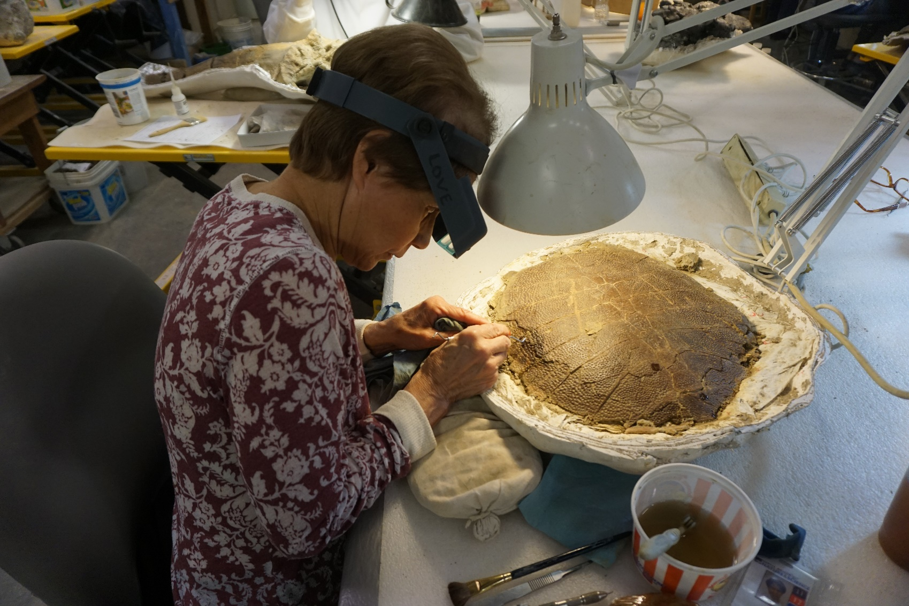
 | STANDARD OPERATING PROCEDURE
 | Mechanical preparation using AIRscribeS
 | Supervisors: |  |  |  |  |  |  |  | Lab manager
 | Laboratory Names: |  |  |  |  |  |  |  | Lab 1, Lab 2
Before the work detailed in this procedure may begin, the intended user must read and understand this document.
This document must be approved by the Lab manager

Overview
This is the standard operation procedure for use of pneumatic airscribes for the preparation of fossils in the fossil preparation labs (ie PaleoTools air scribes models 1-6, etc). These machines produce varying degrees of silica particulate for which safety precautions need to be taken as outlined herein.
Scope
These are the guidelines for safely operating airscribes in the use of fossil preparation and are intended to provide guidance of how to safely employ the required tools for this purpose. Training on the effective use of these tools for preparation is provided as part of the basic fossil preparation course. Refer to the Lab Safety Manual, Sections 4 and 5, for required controls and restrictions.
Potential Hazards
 |  |  | Chemical |  |  |  |  | Pulmonary |  |  |  | Hydraulic |  |  |  |  |  | Electrical |  |  |  | Thermal |  |  | Biological
 |  |  | Mechanical |  |  |  |  | Radiation |  |  |  | Pneumatic |  |  |  |  |  | Fire |  |  |  | Fall |  |  | Other
Hazard Specifics: |  |  |  |  |  | Dust and particulate, loud noise and vibration exposure. Pneumatic hazards for broken or faulty airlines, potential for cuts or punctures from sharp pointed tips of scribes.
Engineering Controls (EC)
 |  |  | Fume hood |  |  |  |  |  |  | Prep/Blast Box |  |  |  |  | Other Local Exhaust |  |  |  |  |  |  | Shielding |  |  | Other
EC Specifics: |  |  |  | When possible, prepare the fossil inside of a prep box to minimize dust exposure to yourself and those around you. If no prep box is available, use a board or other temporary structure on the other side of the fossil from you to minimize hazards on those working around you. Use proper dust extraction equipment, like elephant trunks, positioned as close as possible to the airscribe to reduce inhalation of lingering airborne dust
Training Requirements – must be completed prior to performing the procedure
 |  |  | Basic Fossil Preparation Training
 |  |  | Lab/Work Group Specific Training (specify):
 |  |  | Other (specify):

Required Personal Protective Equipment (PPE)
 |  | Safety glasses |  | Safety goggles |  |  | Face shield & safety glasses |  |  | Face shield & safety goggles
 |  | Lab coat |  | Apron |  |  | Tyvek suit |  |  | Tyvek sleeves
 |  | Gloves |  | Leg coverings |  |  | Hard hat |  |  | Hearing protection
 |  | Respirator |  | Shoes |  |  | Fall protection |  |  | Other
PPE Description: |  |  | Dust masks and dust extractors (elephant trunk or portable) are required if not using a prep box. Particulate respirators required when generating a lot of dust.
Recommended Personal Protective Equipment (PPE)
 | Safety glasses |  |  | Safety goggles |  |  | Face shield & safety glasses |  |  |  |  |  |  | Face shield & safety goggles
 | Lab coat |  |  | Apron |  |  | Tyvek suit |  |  |  |  |  |  | Tyvek sleeves
 | Gloves |  |  | Leg coverings |  |  | Hard hat |  |  |  |  |  |  | Hearing protection
 | Respirator |  |  | Shoes |  |  | Fall protection |  |  |  |  |  |  | Other
PPE Description: |  |  | Minimize accumulation of particles and take home effects on yourself by wearing a lab coat or apron. Wear goggles with heavy usage. Particulates may be flung into eyes. Wear gloves to reduce vibration on hands as well as dust accumulation.
Equipment, Materials, Supplies, & Facility Requirements
For best results, these operations should be done with optivisors, magnifiers, or microscopes whenever possible.

These guidelines apply to all airscribes in the labs, including the following makes and models: Aeromark, Chicago pneumatics, PaleoTools Micro Jack 1-6.
Handling, Work Area & Storage Requirements
Air exhaust systems must be turned on and work area set up appropriately prior to beginning any airscribe work.
Sweep and clean all debris generated. Return all tools and glues to where they belong. All fossils should be stored with their tags and prep records form.
Emergency Response Equipment & Supplies
 | Eyewash |  |  | Fire extinguisher |  |  |  |  | First aid kit |  | Drench hose
 | Safety shower |  |  | Fire blanket |  |  |  |  | Spill kit |  | Other:
Description: |  | Eyewash station and first aid kits are available in labs.

Decontamination & Waste Disposal
All matrix debris should be sifted and all fragments of bone should be retrieved before tossing to make sure no fossil mistakenly ends up in the garbage
Waste consolidants should be emptied into appropriate waste container in satellite accumulation area chemical cabinet. Waste glues should be allowed to cure before disposing in regular waste stream. Uncured glue should be disposed of in metal chemical waste bins.
Waste water cannot be disposed of down drain as it can contain matrix that can clog drain. Throw waste water in plastic bins in sink to dry and then empty bin behind collections building.
All other waste can be disposed of in regular waste stream.
 | Spill Response
 | NA
Stop Work Conditions and Additional Safety Information
Work must stop immediately and the Lab Manager must be notified if tool performance changes unexpectedly, required PPE is unavailable, specimen stability cannot be maintained, or the preparator experiences discomfort, numbness, or reduced control.
Review applicable safety references such as material safety data sheets to ensure appropriate protective measures, spill supplies, and first aid procedures.
If a specimen breaks, stop, photograph the damage, and consolidate if possible. Notify the Lab Manager.

 |  | References
 |  | Procedure
 |  | STEPS
 |  |  |  |  |  |  |  |  |  |  |  |  |  |  |  | Potential Hazards |  |  |  |  |  |  | EC, Haz. Mitigation Device, PPE
 |  | - Use scribe as trained, with the aid of a microscope or optivisors |  |  |  |  |  |  |  |  |  |  |  |  |  | Sharp point on scribe, dust
 |  | 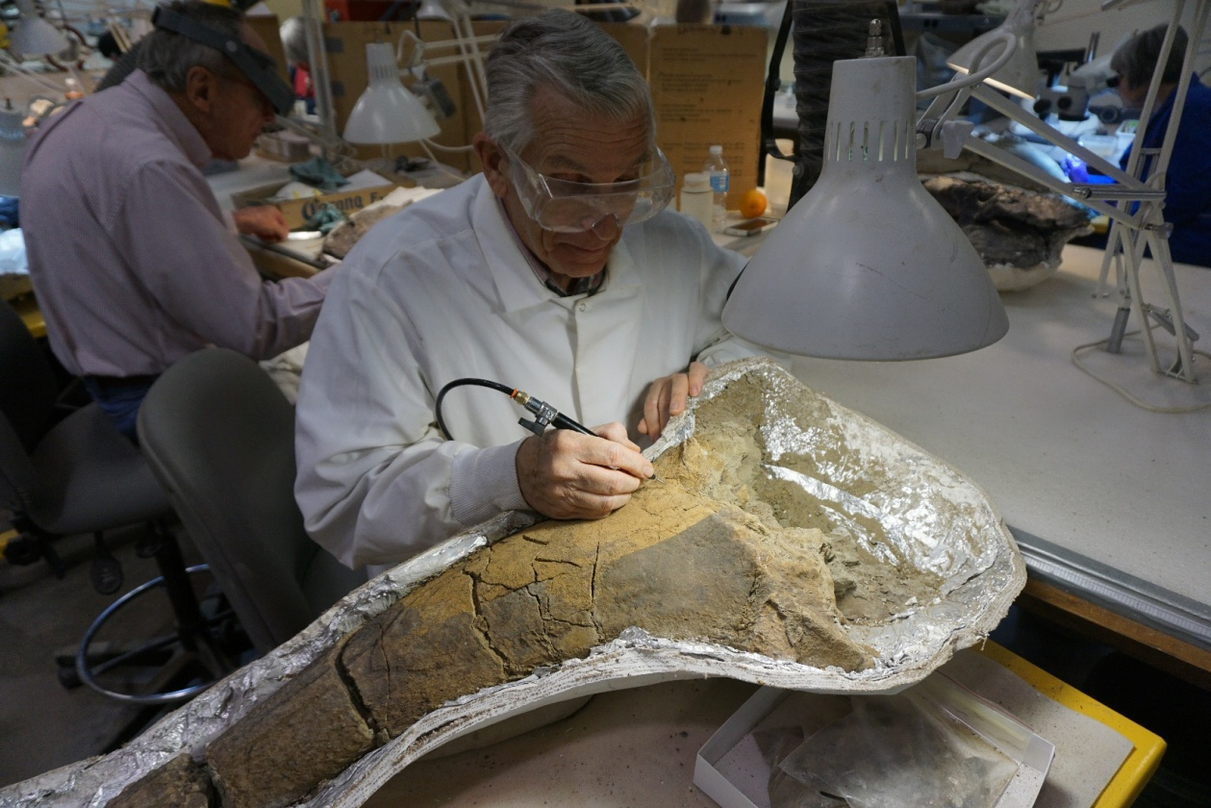
 | STANDARD OPERATING PROCEDURE
 | Mechanical preparation Using air abrasion
 | Supervisors: |  |  |  |  |  |  |  | Lab manager
 | Laboratory Names: |  |  |  |  |  |  |  | Lab 1, Lab 2
Before the work detailed in this procedure may begin, the intended user must read and understand this document.
This document must be approved by the Lab manager

Overview
This is the standard operation procedure for using air abrasion units for fossil preparation. These machines produce varying degrees of silica particulate for which safety precautions need to be taken as outlined herein. They must also be turned on correctly. Only authorized workers may use them.
Scope
These are the guidelines for safe use of air abrasion equipment for fossil preparation. In order to perform this procedure, training on effective use of this equipment for fossil preparation is provided by lab manager as an additional course in air abrasion. These units can be easily damaged and should not be handled by anyone who has not been trained to. Refer to the Lab Safety Manual, Sections 4 and 5, for required controls and restrictions.
Potential Hazards
 |  |  | Chemical |  |  |  |  | Pulmonary |  |  |  | Hydraulic |  |  |  |  |  | Electrical |  |  |  | Thermal |  |  | Biological
 |  |  | Mechanical |  |  |  |  | Radiation |  |  |  | Pneumatic |  |  |  |  |  | Fire |  |  |  | Fall |  |  | Other
Hazard Specifics: |  |  |  |  |  | There is limited risk of contusion from pressurized abrasion particles on skin. Possibility of airborne particulate inhalation.
Engineering Controls (EC)
 |  |  | Fume hood |  |  |  |  |  |  | Prep/Blast Box |  |  |  |  | Other Local Exhaust |  |  |  |  |  |  | Shielding |  |  | Other
EC Specifics: |  |  |  | Dust extractor on sandblasting cabinet must be turned on to evacuate airborne particulate. If abrading outside of cabinet, shielding and portable dust extractors must be used
Training Requirements – must be completed prior to performing the procedure
 |  |  | Basic Fossil Preparation Training
 |  |  | Lab/Work Group Specific Training (specify): |  |  |  |  |  |  |  |  |  | Air Abrasive
 |  |  | Other (specify):

Required Personal Protective Equipment (PPE)
 |  | Safety glasses |  | Safety goggles |  |  | Face shield & safety glasses |  |  | Face shield & safety goggles
 |  | Lab coat |  | Apron |  |  | Tyvek suit |  |  | Tyvek sleeves
 |  | Gloves |  | Leg coverings |  |  | Hard hat |  |  | Hearing protection
 |  | Respirator |  | Shoes |  |  | Fall protection |  |  | Other
PPE Description: |  |  | Particulate respirator and hearing protection should be used for this operation. They are mandatory when procedure is performed outside of sandblasting cabinet
Recommended Personal Protective Equipment (PPE)
 | Safety glasses |  |  | Safety goggles |  |  | Face shield & safety glasses |  |  |  |  |  |  | Face shield & safety goggles
 | Lab coat |  |  | Apron |  |  | Tyvek suit |  |  |  |  |  |  | Tyvek sleeves
 | Gloves |  |  | Leg coverings |  |  | Hard hat |  |  |  |  |  |  | Hearing protection
 | Respirator |  |  | Shoes |  |  | Fall protection |  |  |  |  |  |  | Other
PPE Description: |  |  | Lab coat and heavy duty glove use is recommended to keep dust from accumulating on yourself.
Equipment, Materials, Supplies, & Facility Requirements
Abrasive unit must be turned on exactly as shown during training. Improper startup can lead to damage of unit. Abrasive material should be chosen according to toughness of material being worked on. Be sure to sieve out any clumped abrasive material when refilling, as these will definitely clog abrasive units
Handling, Work Area & Storage Requirements
Unless not possible, all air abrasion should be conducted in one of the enclosed chambers in the oversize prep lab. The inside of the box should be cleaned after every use. Abrasive material should be stored in a clean container in a cool dry place
Emergency Response Equipment & Supplies
 | Eyewash |  |  | Fire extinguisher |  |  |  |  | First aid kit |  | Drench hose
 | Safety shower |  |  | Fire blanket |  |  |  |  | Spill kit |  | Other:
Description: |  | Eyewash station and first aid kits are required available in both labs

Decontamination & Waste Disposal
Work area should be swept clean and used abrasive materials disposed of in trash after every use.
All matrix debris should be sifted and all fragments of bone should be retrieved before tossing to make sure no fossil mistakenly ends up in the garbage
Waste consolidants should be emptied into appropriate waste container in satellite accumulation area chemical cabinet. Waste glues should be allowed to cure before disposing in regular waste stream. Uncured glue should be disposed of in metal chemical waste bins.
Waste water cannot be disposed of down drain as it can contain matrix that can clog drain. Throw waste water in plastic bins in sink to dry and then empty bin behind collections building.
 | Spill Response
 | Any spilled abrasion material should be disposed of. Do not add back to clean material as this can contaminate supply with dirt that can clog machine or change properties of material, rendering it useless.
Stop Work Conditions and Additional Safety Information
Work must stop immediately and the Lab Manager must be notified if tool performance changes unexpectedly, required PPE is unavailable, specimen stability cannot be maintained, or the preparator experiences discomfort, numbness, or reduced control.
Review of applicable safety references such as material safety data sheets to ensure appropriate protective measures, spill supplies, and first aid procedures.
If a specimen breaks, stop, photograph the damage, and consolidate if possible. Notify the Lab Manager.

References

 |  | Procedure
 |  | STEPS
 |  |  |  |  |  |  |  |  |  |  |  |  |  |  |  | Potential Hazards |  |  |  |  |  |  | EC, Haz. Mitigation Device, PPE
 |  | - Put on appropriate PPE
 |  | - Set up specimen in chamber |  |  |  |  |  |  |  |  |  |  |  |  |  | Back and body injury due to manipulation of heavy specimens |  |  |  |  |  |  | Particulate respirator and hearing protection.
 |  | - Turn on air abrasion unit in the order trained
 |  | - Conduct fossil preparation in chamber as per training protocols |  |  |  |  |  |  |  |  |  |  |  |  |  | Airborne particulate directly around work chamber. Loud sound from vacuum unit. |  |  |  |  |  |  | Particulate respirator and hearing protection
 |  | 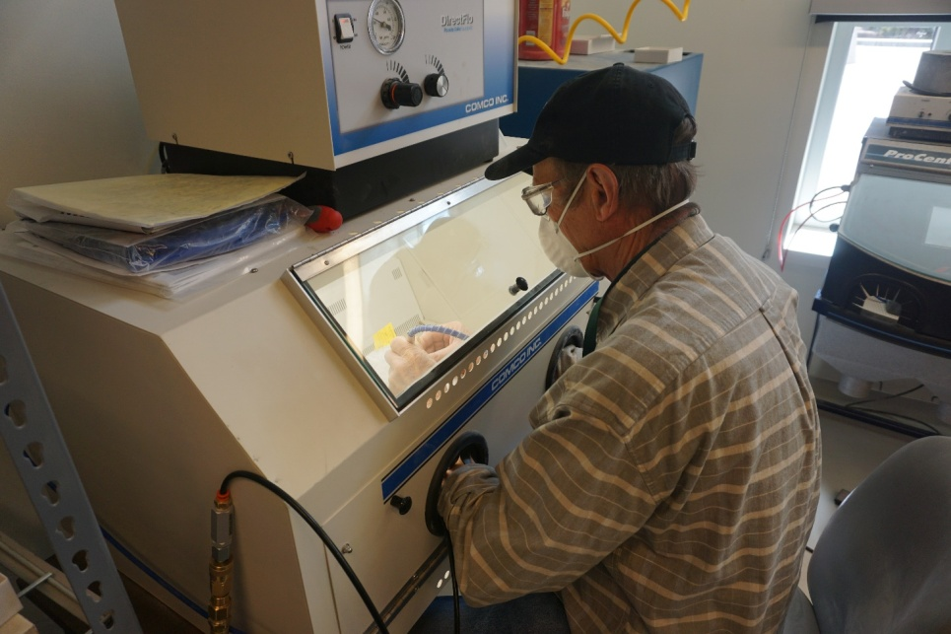
 | STANDARD OPERATING PROCEDURE
 | Mixing and application of PVA consolidants (vinac, acryloid B-72, etc) with Acetone/Alcohol
 | Supervisors: |  |  |  |  |  |  |  | Lab manager
 | Laboratory Names: |  |  |  |  |  |  |  | Lab 1, Lab 2
Before the work detailed in this procedure may begin, the intended user must read and understand this document.
This document must be approved by the Lab manager.

Overview
This is the standard operation procedure for preparing and using PVA consolidants/adhesives in the fossil preparation labs. These are archival plastics that are dissolvable in alcohol or acetone and are used to strengthen or glue pieces of fossils together
Scope
These are the guidelines for the use and safe mixing of PVA consolidants/adhesives and are intended to provide guidance of how to safely employ the required tools and PPE for this purpose Training on the effective use of these tools for preparation is provided as part of the basic fossil preparation volunteer training class. Refer to the Lab Safety Manual, Sections 4 and 5, for required controls and restrictions.
Potential Hazards
 |  |  | Chemical |  |  |  |  | Pulmonary |  |  |  | Hydraulic |  |  |  |  |  | Electrical |  |  |  | Thermal |  |  | Biological
 |  |  | Mechanical |  |  |  |  | Radiation |  |  |  | Pneumatic |  |  |  |  |  | Fire |  |  |  | Fall |  |  | Other
Hazard Specifics: |  |  |  |  |  | Organic vapor fumes. Also highly flammable
Engineering Controls (EC)
 |  |  | Fume hood |  |  |  |  |  |  | Biosafety Cabinet |  |  |  |  | Other Local Exhaust |  |  |  |  |  |  | Shielding |  |  | Other
EC Specifics: |  |  |  | Mixing of larger quantities of PVA consolidants is to be done under fume hood or the casting/molding room. When applying, use local exhaust to draw from face.
Training Requirements – must be completed prior to performing the procedure
 |  |  | Basic Fossil Preparation Training
 |  |  | Lab/Work Group Specific Training (specify):
 |  |  | Other (specify):

Required Personal Protective Equipment (PPE)
 |  | Safety glasses |  | Safety goggles |  |  | Face shield & safety glasses |  |  | Face shield & safety goggles
 |  | Lab coat |  | Apron |  |  | Tyvek suit |  |  | Tyvek sleeves
 |  | Gloves |  | Leg coverings |  |  | Hard hat |  |  | Hearing protection
 |  | Respirator |  | Shoes |  |  | Fall protection |  |  | Other
PPE Description: |  |  | Eye protection, a lab coat and Nitrile gloves are required specifically for mixing batches of PVA. Respiratory protection is required if working with PVA powder, large quantities of solvent or without adequate ventilation. This is unnecessary for PVA beads.
Recommended Personal Protective Equipment (PPE)
 | Safety glasses |  |  | Safety goggles |  |  | Face shield & safety glasses |  |  |  |  |  |  | Face shield & safety goggles
 | Lab coat |  |  | Apron |  |  | Tyvek suit |  |  |  |  |  |  | Tyvek sleeves
 | Gloves |  |  | Leg coverings |  |  | Hard hat |  |  |  |  |  |  | Hearing protection
 | Respirator |  |  | Shoes |  |  | Fall protection |  |  |  |  |  |  | Other
PPE Description:
Equipment, Materials, Supplies, & Facility Requirements
Funnels should be used to reduce the possibility of spills. PVA consolidants (Vinac, B 72) should be added to acetone or alcohol, not the other way around. Work should be conducted in a fume hood when making large batches.

Use plastic paint brushes. Do not use Applicators with painted handles, ie wood brushes, as acetone will strip paint and color glue supply which will discolor fossils.
Handling, Work Area & Storage Requirements
Mixing of consolidants is done in the casting and molding lab with ventilation on or in a fume hood. If adequate ventilation is not accessible, a respirator with an organic filter should be worn. (Mother)mixes should be stored in a flammable cabinet when not in use.
Do not mix with water. Throw away any supply that is contaminated with water.
Emergency Response Equipment & Supplies
 | Eyewash |  |  | Fire extinguisher |  |  |  |  | First aid kit |  | Drench hose
 | Safety shower |  |  | Fire blanket |  |  |  |  | Spill kit |  | Other:
Description: |  | Eyewash station, spill kits and first aid kits are required available in both labs

Decontamination & Waste Disposal
Work area should be wiped clean with acetone where necessary and materials disposed of in chemical trash can while wearing PPE.
Waste consolidants should be emptied into appropriate waste container in satellite accumulation area chemical cabinet.

Do not pour acetone down drains. Do not put soaked paper towels in nonhazardous waste receptacles. Do not leave soaked material on counters to dry. Do not use Alcohol or Acetone to wash consolidant off skin.

Waste glues should be allowed to cure before disposing in regular waste stream. Uncured glue should be disposed of in metal chemical waste bins.
 | Spill Response
 | Spills should be wiped up with a small amount of acetone and paper towel to remove PVA residue. Allow for surface to dry before resuming work. If spilled on self, you can wash your hands before it dries. Otherwise allow to dry and rub off of hands. Wash remaining material off.
Stop Work Conditions and Additional Safety Information
Work must stop immediately and the Lab Manager must be notified if tool performance changes unexpectedly, required PPE is unavailable, specimen stability cannot be maintained, or the preparator experiences discomfort, numbness, or reduced control.
Review of applicable safety references such as material safety data sheets to ensure appropriate protective measures, spill supplies, and first aid procedures.
If a specimen breaks, stop, photograph the damage, and consolidate if possible. Notify the Lab Manager.

References

Procedure
 | Potential Hazards | EC, Haz. Mitigation Device, PPE
STEPS: Mixing
- Decant Acetone/Alcohol into smaller containers | Organic vapor fumes | lab coat, nitrile gloves, respirator (if ventilation is inadequate)
- Pour PVA granules in batches using funnels to avoid spillage and mix under fume hood | Organic vapor fumes | lab coat, nitrile gloves, respirator (if ventilation is inadequate)
STEPS: Application
- Apply a thin solution of PVA glue to both sides of a broken fossil (if not already consolidated since break) | Organic vapor fumes | lab coat, nitrile gloves, respirator (if ventilation is inadequate)
- Apply a layer of thick PVA glue solution to one side of the break | Organic vapor fumes | lab coat, nitrile gloves, respirator (if ventilation is inadequate)
- Join pieces together | Organic vapor fumes | lab coat, nitrile gloves, respirator (if ventilation is inadequate)
- Clean any excess glue on specimen before it sets | Organic vapor fumes | lab coat, nitrile gloves, respirator (if ventilation is inadequate)
- Maintain join as trained while it dries

 | STANDARD OPERATING PROCEDURE
 | Mixing/Decanting and application of reactive adhesives (cyanoacrylate, Epoxy)
 | Supervisors: |  |  |  |  |  |  | Lab manager
 | Laboratory Names: |  |  |  |  |  |  | Lab 1, Lab 2
Before the work detailed in this procedure may begin, the intended user must read and understand this document.
This document must be approved by the Lab manager

Overview
This is the standard operation procedure for the use of reactive adhesives in the fossil preparation labs. These are “permanent/instant” glues that are used to quickly and strongly adhere specimen pieces together.
Scope
These are the guidelines for safe use of reactive adhesives and are intended to provide guidance of how to safely employ the required tools and PPE for this purpose. Training on adhesives is provided as part of the basic fossil preparation course. Refer to the Lab Safety Manual, Sections 4 and 5, for required controls and restrictions.
Potential Hazards
 |  | Chemical |  |  |  |  | Pulmonary |  |  |  | Hydraulic |  |  |  |  | Electrical |  |  |  | Thermal |  | Biological
 |  | Mechanical |  |  |  |  | Radiation |  |  |  | Pneumatic |  |  |  |  | Fire |  |  |  | Fall |  | Other
Hazard Specifics: |  |  |  |  | Organic vapor fumes from chemical reactions in adhesives. Epoxy in particular is highly exothermic
Engineering Controls (EC)
 |  | Fume hood |  |  |  |  |  |  | Biosafety Cabinet |  |  |  |  | Other Local Exhaust |  |  |  |  |  | Shielding |  | Other
EC Specifics: |  |  | Decanting, mixing and application of larger quantities (more than 10cc) of reactive adhesives should be conducted under the fume hood.
Training Requirements – must be completed prior to performing the procedure
 |  | Basic Fossil Preparation Training
 |  | Lab/Work Group Specific Training (specify):
 |  | Other (specify):

Required Personal Protective Equipment (PPE)
 |  | Safety glasses |  | Safety goggles |  |  | Face shield & safety glasses |  |  | Face shield & safety goggles
 |  | Lab coat |  | Apron |  |  | Tyvek suit |  |  | Tyvek sleeves
 |  | Gloves |  | Leg coverings |  |  | Hard hat |  |  | Hearing protection
 |  | Respirator |  | Shoes |  |  | Fall protection |  |  | Other
PPE Description: |  |  | Eye protection, a lab coat and Nitrile gloves are required for application of larger quantities (more than 10cc) of reactive adhesives
Recommended Personal Protective Equipment (PPE)
 | Safety glasses |  |  | Safety goggles |  |  | Face shield & safety glasses |  |  |  |  |  |  | Face shield & safety goggles
 | Lab coat |  |  | Apron |  |  | Tyvek suit |  |  |  |  |  |  | Tyvek sleeves
 | Gloves |  |  | Leg coverings |  |  | Hard hat |  |  |  |  |  |  | Hearing protection
 | Respirator |  |  | Shoes |  |  | Fall protection |  |  |  |  |  |  | Other
PPE Description: |  |  | Nitrile gloves and lab coat are recommended whenever using reactive adhesives. Organic vapor respirators are recommended for when applying reactive adhesives outside of the fume hood
Equipment, Materials, Supplies, & Facility Requirements
Reactive adhesives are mixed and applied according to lab training protocols
Handling, Work Area & Storage Requirements
Mixing and application of larger quantities of reactive adhesives must be done under a fume hood or outdoors
Emergency Response Equipment & Supplies
 | Eyewash |  |  | Fire extinguisher |  |  |  |  | First aid kit |  | Drench hose
 | Safety shower |  |  | Fire blanket |  |  |  |  | Spill kit |  | Other:
Description: |  | Eyewash station and first aid kits are available in both labs. No quick way to clean if it gets on your skin, so wear gloves.

Decontamination & Waste Disposal
Work area should be wiped clean with acetone where necessary and materials disposed of in trash can while wearing PPE.
Waste glues should be allowed to cure before disposing in regular waste stream. Uncured glue should be disposed of in metal chemical waste bins.
Do not put uncured paper towels in nonhazardous waste receptacles. Do not leave uncured material exposed on counters to dry. Do not use Alcohol or Acetone to wash glue off skin.

All other waste can be disposed of in regular waste stream.
 | Spill Response
 | Spills should be wiped up immediately with paper towels as quickly as possible before these materials set up and harden, wearing PPE. Any residual films should be allowed to cure, scraped up and disposed of in trash can
Stop Work Conditions and Additional Safety Information
Work must stop immediately and the Lab Manager must be notified if tool performance changes unexpectedly, required PPE is unavailable, specimen stability cannot be maintained, or the preparator experiences discomfort, numbness, or reduced control.
Review of applicable safety references such as material safety data sheets to ensure appropriate protective measures, spill supplies, and first aid procedures.
If a specimen breaks, stop, photograph the damage, and consolidate if possible. Notify the Lab Manager.

References

Procedure
STEPS
 | Potential Hazards | EC, Haz. Mitigation Device, PPE
- Epoxy – Mix both parts in equal amounts | Adhesive on skin, respiratory hazard | Nitrole gloves, organic filter on respirator
- Apply adhesive to specimen prepared in advance in sandbox | Adhesive on skin or clothing, respiratory hazard | lab coat, nitrile gloves recommended, organic filter on respirator
- Clean any excess glue on specimen before it sets | Adhesive on skin or clothing, respiratory hazard | lab coat, nitrile gloves, respirator (if ventilation is inadequate)
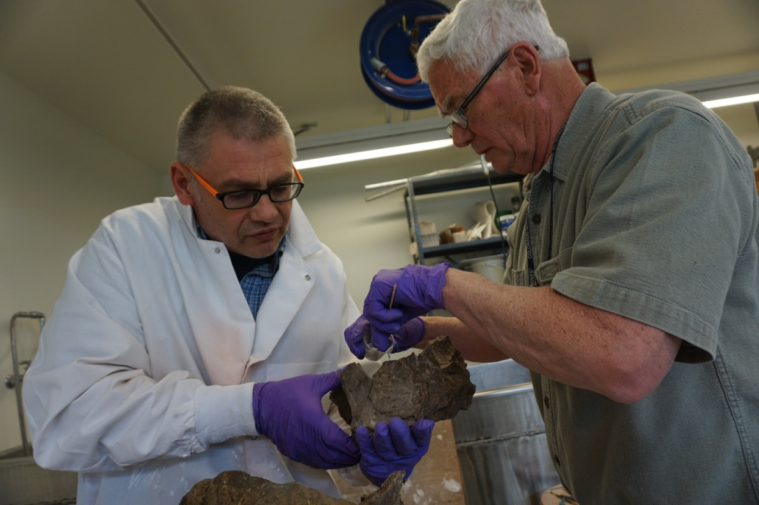

 | STANDARD OPERATING PROCEDURE
 | Support Jacket/Cradle Making
 | Supervisors: |  |  |  |  |  |  | Lab manager
 | Laboratory Names: |  |  |  |  |  |  | Lab 1, Lab 2
Before the work detailed in this procedure may begin, the intended user must read and understand this document.
This document must be approved by the Lab manager.

Overview
This is the standard operation procedure for construction of jackets and archival grade cradles in fossil preparation labs. These are fossil support structures made of fiberglass or burlap embedded in gypsum cement lined with paper, ethafoam or archival felt as a separator used for storing fossils.
Scope
These are the guidelines for safely constructing fossil cradles/jackets. These are intended to provide guidance on how to safely employ the required tools and PPE for this purpose. Training on cradle/jacket construction is provided as a separate course during basic prep training. Refer to the Lab Safety Manual, Sections 4 and 5, for required controls and restrictions.
Potential Hazards
 |  | Chemical |  |  |  |  | Pulmonary |  |  |  | Hydraulic |  |  |  |  | Electrical |  |  |  | Thermal |  | Biological
 |  | Mechanical |  |  |  |  | Radiation |  |  |  | Pneumatic |  |  |  |  | Fire |  |  |  | Fall |  | Other
Hazard Specifics: |  |  |  |  | Dust exposure and plaster on bare skin.
Engineering Controls (EC)
 |  | Fume hood |  |  |  |  |  |  | Biosafety Cabinet |  |  |  |  | Other Local Exhaust |  |  |  |  |  | Shielding |  | Other
EC Specifics: |  |  | Turn on all exhaust fans and use portable dust extractors near site of particulate generation if working indoors.
Training Requirements – must be completed prior to performing the procedure
 |  | Basic Fossil Preparation Training
 |  | Lab/Work Group Specific Training (specify): |  |  |  |  |  |  |  |  |  | Cradle-making
 |  | Other (specify):

Required Personal Protective Equipment (PPE)
 |  | Safety glasses |  | Safety goggles |  |  | Face shield & safety glasses |  |  | Face shield & safety goggles
 |  | Lab coat |  | Apron |  |  | Tyvek suit |  |  | Tyvek sleeves
 |  | Gloves |  | Leg coverings |  |  | Hard hat |  |  | Hearing protection
 |  | Respirator |  | Shoes |  |  | Fall protection |  |  | Other
PPE Description: |  |  | Lab coat, heavy duty gloves and particulate respirators are required when using fiberglass.
Recommended Personal Protective Equipment (PPE)
 | Safety glasses |  |  | Safety goggles |  |  | Face shield & safety glasses |  |  |  |  |  |  | Face shield & safety goggles
 | Lab coat |  |  | Apron |  |  | Tyvek suit |  |  |  |  |  |  | Tyvek sleeves
 | Gloves |  |  | Leg coverings |  |  | Hard hat |  |  |  |  |  |  | Hearing protection
 | Respirator |  |  | Shoes |  |  | Fall protection |  |  |  |  |  |  | Other
PPE Description: |  |  | Use of lab coat for plastering operations with burlap is recommended but not required.
Equipment, Materials, Supplies, & Facility Requirements
These guidelines are intended when working with all types of fiberglass and gypsum cement.
Handling, Work Area & Storage Requirements
Work areas are to be set up as demonstrated in training. Cover all surfaces that need to be protected from uncured plaster and plaster dust. Make sure plaster supply is covered when finished. While less of a concern here, humidity can ruin plaster.
Emergency Response Equipment & Supplies
 | Eyewash |  |  | Fire extinguisher |  |  |  |  | First aid kit |  | Drench hose
 | Safety shower |  |  | Fire blanket |  |  |  |  | Spill kit |  | Other:
Description: |  | Eyewash station and first aid kits are available in both labs

Decontamination & Waste Disposal
Unused plaster should never be disposed of down drains. It should always be allowed to harden and then disposed of in garbage as is typical for non-toxic solid waste.
All matrix debris should be sifted and all fragments of bone should be retrieved before tossing to make sure no fossil mistakenly ends up in the garbage
Waste consolidants should be emptied into appropriate waste container in satellite accumulation area waste cabinet.
Waste water cannot be disposed of down drain as it can clog drain. Throw waste water in plastic bins in sink to dry and then empty bin behind collections building.
 | Spill Response
 | Plaster spills are non-toxic and can simply be wiped up, allowed to dry, and disposed of as solid waste.
Stop Work Conditions and Additional Safety Information
Work must stop immediately and the Lab Manager must be notified if tool performance changes unexpectedly, required PPE is unavailable, specimen stability cannot be maintained, or the preparator experiences discomfort, numbness, or reduced control.
Review of applicable safety references such as material safety data sheets to ensure appropriate protective measures, spill supplies, and first aid procedures.
If a specimen breaks, stop, photograph the damage, and consolidate if possible. Notify the Lab Manager.

References

Procedure
STEPS
 | Potential Hazards | EC, Haz. Mitigation Device, PPE
- Cut burlap or fiberglass matt as necessary. | Fiberglass fibers can be a respiratory and skin irritant | lab coat, nitrile gloves, particulate respirator
- Mix gypsum cement and apply as trained to construct cradle/jacket | Plaster and fiberglass can be skin irritants | lab coat, nitrile gloves, (particulate respirator when using fiberglass)
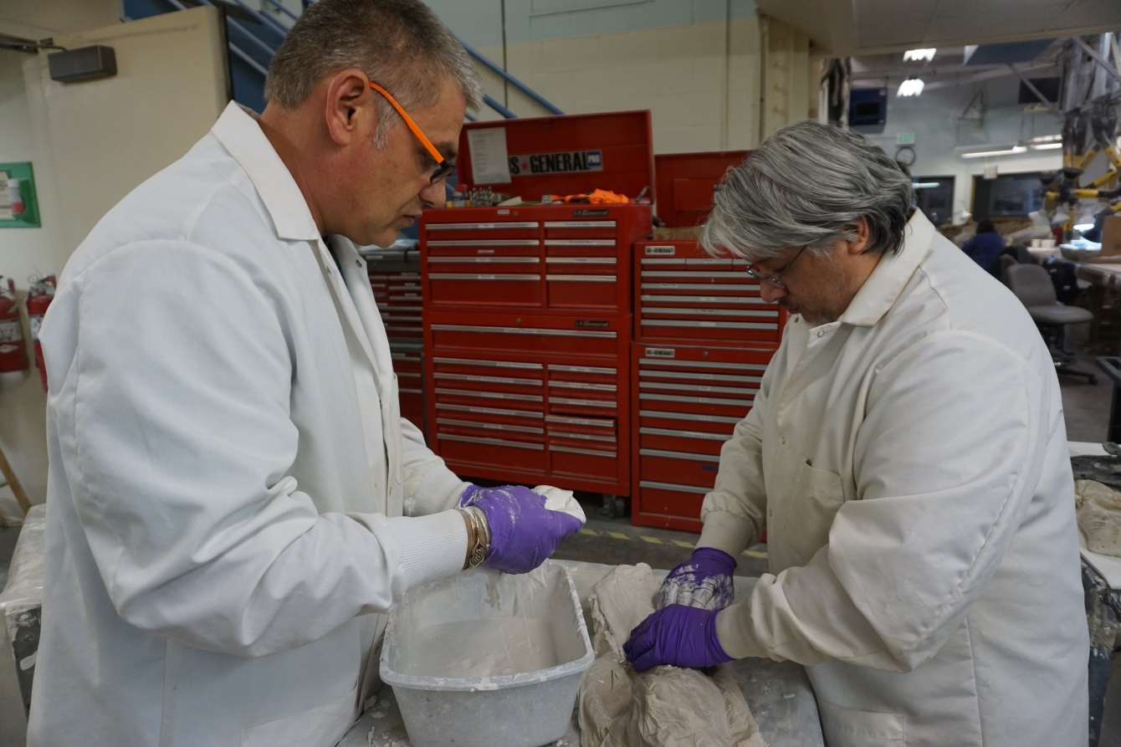

 | STANDARD OPERATING PROCEDURE
 | cast cutter/multi-tool use for Jacket cutting
 | Supervisors: |  |  |  |  |  |  | Lab manager
 | Laboratory Names: |  |  |  |  |  |  | Lab 1, Lab 2
Before the work detailed in this procedure may begin, the intended user must read and understand this document.
This document must be approved by the Lab manager.

Overview
This is the standard operation procedure for using a cast cutter/multi-tool for opening fossil jackets
Scope
These are the guidelines for safely opening fossil jackets using a cast cutter/multi-tool. These are intended to provide guidance on how to safely employ the tool and the required PPE for this purpose. Training on cradle/jacket construction is provided as a separate course during basic prep training. Refer to the Lab Safety Manual, Sections 4 and 5, for required controls and restrictions.
Potential Hazards
 |  | Chemical |  |  |  |  | Pulmonary |  |  |  | Hydraulic |  |  |  |  | Electrical |  |  |  | Thermal |  | Biological
 |  | Mechanical |  |  |  |  | Radiation |  |  |  | Pneumatic |  |  |  |  | Fire |  |  |  | Fall |  | Other
Hazard Specifics: |  |  |  |  | Vibrating blade has limited potential to cut skin, and produces minimal plaster dust. Vibration exposure from tools
Engineering Controls (EC)
 |  | Fume hood |  |  |  |  |  |  | Biosafety Cabinet |  |  |  |  | Other Local Exhaust |  |  |  |  |  | Shielding |  | Other
EC Specifics: |  |  | Volunteers are not allowed to use power tools unsupervised. Additional use of vacuum is not necessary when using the cast cutter, as dust generation is minimal
Training Requirements – must be completed prior to performing the procedure
 |  | Basic Fossil Preparation Training
 |  | Lab/Work Group Specific Training (specify):
 |  | Other (specify):

Required Personal Protective Equipment (PPE)
 |  | Safety glasses |  | Safety goggles |  |  | Face shield & safety glasses |  |  | Face shield & safety goggles
 |  | Lab coat |  | Apron |  |  | Tyvek suit |  |  | Tyvek sleeves
 |  | Gloves |  | Leg coverings |  |  | Hard hat |  |  | Hearing protection
 |  | Respirator |  | Shoes |  |  | Fall protection |  |  | Other
PPE Description: |  |  | Given the limited dust and risk of cutting no PPE is required when using a cast cutter
Recommended Personal Protective Equipment (PPE)
 | Safety glasses |  |  | Safety goggles |  |  | Face shield & safety glasses |  |  |  |  |  |  | Face shield & safety goggles
 | Lab coat |  |  | Apron |  |  | Tyvek suit |  |  |  |  |  |  | Tyvek sleeves
 | Gloves |  |  | Leg coverings |  |  | Hard hat |  |  |  |  |  |  | Hearing protection
 | Respirator |  |  | Shoes |  |  | Fall protection |  |  |  |  |  |  | Other
PPE Description: |  |  | Lab coat and particulate respirator use is recommended for minimal exposure to plaster dust. Gloves recommended to minimize vibration effects
Equipment, Materials, Supplies, & Facility Requirements
These guidelines are intended for any cutting operations using the cast cutter or mult-tool to open and trim small jackets
Handling, Work Area & Storage Requirements
None for cast cutting. For anything else, ventilation is required
Emergency Response Equipment & Supplies
 | Eyewash |  |  | Fire extinguisher |  |  |  |  | First aid kit |  | Drench hose
 | Safety shower |  |  | Fire blanket |  |  |  |  | Spill kit |  | Other:
Description: |  | Eyewash station and first aid kits are required available in both labs

Decontamination & Waste Disposal
Work area should be swept clean and materials disposed of in trash.
All matrix debris should be sifted and all fragments of bone should be retrieved before tossing to make sure no fossil mistakenly ends up in the garbage
 | Spill Response
 | N/A
Stop Work Conditions and Additional Safety Information
Work must stop immediately and the Lab Manager must be notified if tool performance changes unexpectedly, required PPE is unavailable, specimen stability cannot be maintained, or the preparator experiences discomfort, numbness, or reduced control.
Review of applicable safety references such as material safety data sheets to ensure appropriate protective measures, spill supplies, and first aid procedures.
If a specimen breaks, stop, photograph the damage, and consolidate if possible. Notify the Lab Manager.

References

Procedure
STEPS
 | Potential Hazards | EC, Haz. Mitigation Device, PPE
- Cut jackets according to training | Minimal exposure to plaster dust | lab coat and respirator recommended.

 | STANDARD OPERATING PROCEDURE
 | Angle Grinder use for Jacket and Rock cutting
 | Supervisors: |  |  |  |  |  |  | Lab manager
 | Laboratory Names: |  |  |  |  |  |  | Lab 1, Lab 2
Before the work detailed in this procedure may begin, the intended user must read and understand this document.
This document must be approved by the Lab manager

Overview
This is the standard operation procedure for safe use of angle grinders in the fossil preparation labs.
Scope
These are the guidelines for safely constructing fossil support cradles and are intended to provide guidance of how to safely employ the required tools and PPE for this purpose. Training on grinder use for cradle construction or jacket cutting is provided additionally by lab staff as necessary. Refer to the Lab Safety Manual, Sections 4 and 5, for required controls and restrictions.
Potential Hazards
 |  | Chemical |  |  |  |  | Pulmonary |  |  |  | Hydraulic |  |  |  |  | Electrical |  |  |  | Thermal |  | Biological
 |  | Mechanical |  |  |  |  | Radiation |  |  |  | Pneumatic |  |  |  |  | Fire |  |  |  | Fall |  | Other
Hazard Specifics: |  |  |  |  | High speed rotating blade has potential to cut skin; potential silica, fiberglass or plaster dust exposure depending on materials being cut. Exposure to vibrations from tool.
Engineering Controls (EC)
 |  | Fume hood |  |  |  |  |  |  | Biosafety Cabinet |  |  |  |  | Other Local Exhaust |  |  |  |  |  | Shielding |  | Other
EC Specifics: |  |  | Volunteers are not allowed to use power tools unsupervised. A hand held vacuum should be used along with the local exhaust system to control dust.
Training Requirements – must be completed prior to performing the procedure
 |  | Basic Fossil Preparation Training
 |  | Lab/Work Group Specific Training (specify):
 |  | Other (specify):

Required Personal Protective Equipment (PPE)
 |  | Safety glasses |  | Safety goggles |  |  | Face shield & safety glasses |  |  | Face shield & safety goggles
 |  | Lab coat |  | Apron |  |  | Tyvek suit |  |  | Tyvek sleeves
 |  | Gloves |  | Leg coverings |  |  | Hard hat |  |  | Hearing protection
 |  | Respirator |  | Shoes |  |  | Fall protection |  |  | Other
PPE Description: |  |  | Lab coat, hearing protection, safety glasses and particulate respirators are required when cutting. Additionally the person handling the grinder must wear leather gloves to protect hands from blade and vibrations.
Recommended Personal Protective Equipment (PPE)
 | Safety glasses |  |  | Safety goggles |  |  | Face shield & safety glasses |  |  |  |  |  |  | Face shield & safety goggles
 | Lab coat |  |  | Apron |  |  | Tyvek suit |  |  |  |  |  |  | Tyvek sleeves
 | Gloves |  |  | Leg coverings |  |  | Hard hat |  |  |  |  |  |  | Hearing protection
 | Respirator |  |  | Shoes |  |  | Fall protection |  |  |  |  |  |  | Other
PPE Description: |  |  | Heavy duty gloves are also recommended when cutting fiberglass jackets
Equipment, Materials, Supplies, & Facility Requirements
These guidelines are intended for any cutting operations using the angle grinder, including rock, fiberglass and burlap jackets and support cradles
Handling, Work Area & Storage Requirements
Where possible, large cutting operations should be conducted outdoors. When cutting in either lab, work areas are to be set up as demonstrated in training.
Emergency Response Equipment & Supplies
 | Eyewash |  |  | Fire extinguisher |  |  |  |  | First aid kit |  | Drench hose
 | Safety shower |  |  | Fire blanket |  |  |  |  | Spill kit |  | Other:
Description: |  | Eyewash station and first aid kits are required available in both labs

Decontamination & Waste Disposal
Work area should be swept clean and materials disposed of in trash can while wearing PPE.
 | Spill Response
 | N/A
Stop Work Conditions and Additional Safety Information
Work must stop immediately and the Lab Manager must be notified if tool performance changes unexpectedly, required PPE is unavailable, specimen stability cannot be maintained, or the preparator experiences discomfort, numbness, or reduced control.
Review of applicable safety references such as material safety data sheets to ensure appropriate protective measures, spill supplies, and first aid procedures.
If a specimen breaks, stop, photograph the damage, and consolidate if possible. Notify the Lab Manager.

References

Procedure
STEPS
 | Potential Hazards | EC, Haz. Mitigation Device, PPE
- Put on all required PPE
- Cut materials with dust extraction in position according to lab specific training. | Dust and Fiberglass fibers can be a respiratory and skin irritant | lab coat, nitrile or leather gloves, particulate respirator, safety glasses
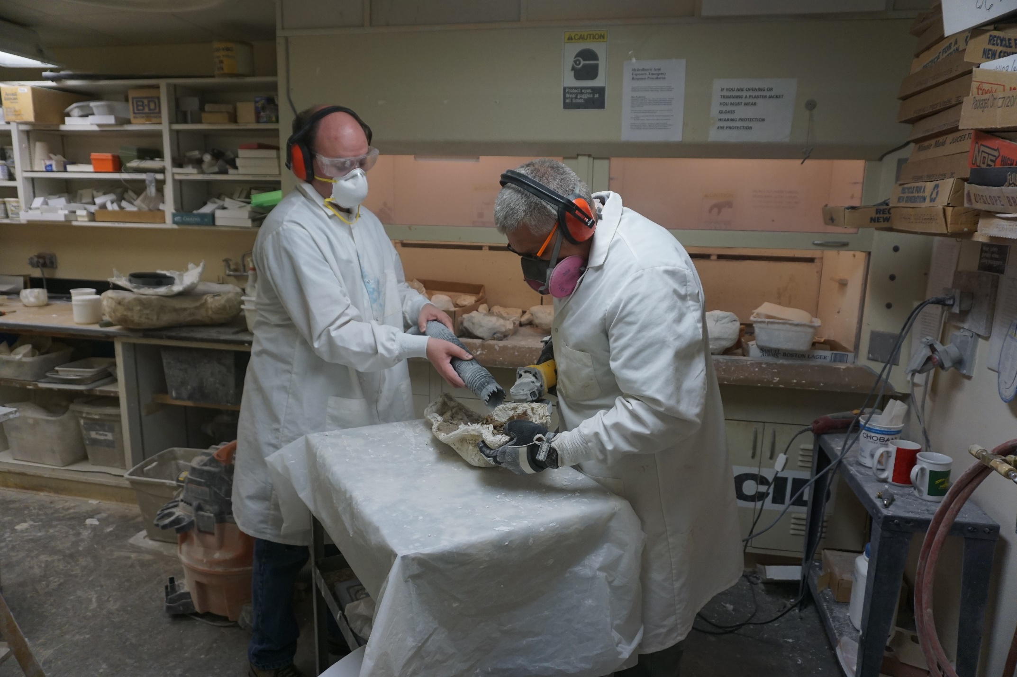

 | STANDARD OPERATING PROCEDURE
 | Molding Fossil Specimens
 | Supervisors: |  |  |  |  |  |  | Lab manager
 | Laboratory Names: |  |  |  |  |  |  | Lab 1, Lab 2
Before the work detailed in this procedure may begin, the intended user must read and understand this document.
This document must be approved by the Lab manager

Overview
This is the standard operation procedure for constructing molds of fossil specimens for casting, including all associated operations, such as claying the specimen, pouring room temperature vulcanization (RTV) silicone and making mold supports with plaster.
Scope
These are the guidelines for the safe construction of fossil specimen molds and are intended to provide guidance of how to safely employ the required tools and PPE for this purpose. Training on molding fossils is provided by lab staff as part of the Casting and Molding course. Refer to the Lab Safety Manual, Sections 4 and 5, for required controls and restrictions.
Potential Hazards
 |  | Chemical |  |  |  |  | Pulmonary |  |  |  | Hydraulic |  |  |  |  | Electrical |  |  |  | Thermal |  | Biological
 |  | Mechanical |  |  |  |  | Radiation |  |  |  | Pneumatic |  |  |  |  | Fire |  |  |  | Fall |  | Other
Hazard Specifics: |  |  |  |  | Organic vapor fumes from acetone and paint thinner
Engineering Controls (EC)
 |  | Fume hood |  |  |  |  |  |  | Biosafety Cabinet |  |  |  |  | Other Local Exhaust |  |  |  |  |  | Shielding |  | Other
EC Specifics: |  |  | Use of demolding sprays and agents is to be done under fume hood
Training Requirements – must be completed prior to performing the procedure
 |  | Basic Fossil Preparation Training
 |  | Lab/Work Group Specific Training (specify): |  |  |  |  |  |  |  |  |  | Casting and Molding
 |  | Other (specify):

Required Personal Protective Equipment (PPE)
 |  | Safety glasses |  | Safety goggles |  |  | Face shield & safety glasses |  |  | Face shield & safety goggles
 |  | Lab coat |  | Apron |  |  | Tyvek suit |  |  | Tyvek sleeves
 |  | Gloves |  | Leg coverings |  |  | Hard hat |  |  | Hearing protection
 |  | Respirator |  | Shoes |  |  | Fall protection |  |  | Other
PPE Description: |  |  | A lab coat and Nitrile gloves are required for these operations.
Recommended Personal Protective Equipment (PPE)
 | Safety glasses |  |  | Safety goggles |  |  | Face shield & safety glasses |  |  |  |  |  |  | Face shield & safety goggles
 | Lab coat |  |  | Apron |  |  | Tyvek suit |  |  |  |  |  |  | Tyvek sleeves
 | Gloves |  |  | Leg coverings |  |  | Hard hat |  |  |  |  |  |  | Hearing protection
 | Respirator |  |  | Shoes |  |  | Fall protection |  |  |  |  |  |  | Other
PPE Description: |  |  | Use of organic vapor respirators are recommended whenever using solvents or inadequate ventilation
Equipment, Materials, Supplies, & Facility Requirements
These guidelines are intended handling for use of all materials for molding specimens including plastacine clay, plaster, RTV silicone, acetone and paint thinner.
Handling, Work Area & Storage Requirements
An area to store curing specimens undisturbed is needed. Any operations involving larger volumes (>10 cc) of solvents are to be done under a fume hood in the casting lab.
Emergency Response Equipment & Supplies
 | Eyewash |  |  | Fire extinguisher |  |  |  |  | First aid kit |  | Drench hose
 | Safety shower |  |  | Fire blanket |  |  |  |  | Spill kit |  | Other:
Description: |  | Eyewash station and first aid kits are required available in both labs

Decontamination & Waste Disposal
Work area should be wiped clean with acetone where necessary and materials disposed of in trash can while wearing PPE.
Waste material should be allowed to cure before disposing in regular waste stream. Uncured material should be disposed of in metal chemical waste bins.
All other waste can be disposed of in regular waste stream.
 | Spill Response
 | Spills should be wiped up with a small amount of acetone and paper towel to remove any clay/ silicone residue.
Stop Work Conditions and Additional Safety Information
Work must stop immediately and the Lab Manager must be notified if material performance changes unexpectedly, required PPE is unavailable, specimen stability cannot be maintained, or the preparator experiences discomfort, numbness, or reduced control.
Review of applicable safety references such as material safety data sheets to ensure appropriate protective measures, spill supplies, and first aid procedures.
If a specimen breaks, stop, photograph the damage, and consolidate if possible. Notify the Lab Manager.

References
Procedure
STEPS
 | Potential Hazards | EC, Haz. Mitigation Device, PPE
- Build a clay base and dam/wall around the specimen
- RTV silicone is poured around specimen | Organic vapor fumes when using acetone or paint thinner for cleanup and smoothing clay | Nitrile gloves for applying RTV. Organic vapor mask when using solvents for smoothing.
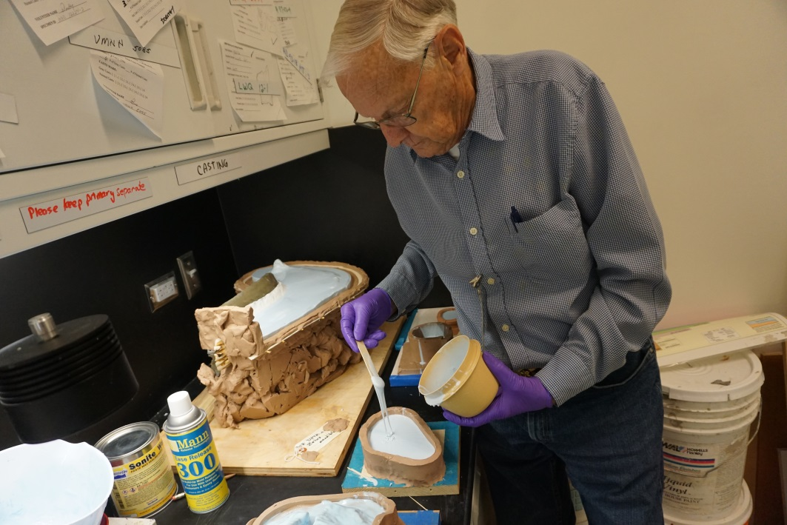

 | STANDARD OPERATING PROCEDURE
 | Casting Fossil Specimen Molds
 | Supervisors: |  |  |  |  |  |  | Lab manager
 | Laboratory Names: |  |  |  |  |  |  | Lab 1, Lab 2
Before the work detailed in this procedure may begin, the intended user must read and understand this document.
This document must be approved by the Lab manager.

Overview
This is the standard operation procedure for pouring casting resin into molds of fossil specimens in the fossil preparation labs.
Scope
These are the guidelines for safely pouring fossil specimen casts and are intended to provide guidance of how to safely employ the required tools and PPE for this purpose. Training on casting fossils is provided by lab staff as part of the casting and molding course. Refer to the Lab Safety Manual, Sections 4 and 5, for required controls and restrictions.
Potential Hazards
 |  | Chemical |  |  |  |  | Pulmonary |  |  |  | Hydraulic |  |  |  |  | Electrical |  |  |  | Thermal |  | Biological
 |  | Mechanical |  |  |  |  | Radiation |  |  |  | Pneumatic |  |  |  |  | Fire |  |  |  | Fall |  | Other
Hazard Specifics: |  |  |  |  | Organic vapor fumes from polyester
Engineering Controls (EC)
 |  | Fume hood |  |  |  |  |  |  | Biosafety Cabinet |  |  |  |  | Other Local Exhaust |  |  |  |  |  | Shielding |  | Other
EC Specifics: |  |  | Pouring casts of polyester is only to be done under fume hood
Training Requirements – must be completed prior to performing the procedure
 |  | Basic Fossil Preparation Training
 |  | Lab/Work Group Specific Training (specify): |  |  |  |  |  |  |  |  |  | Casting and Molding
 |  | Other (specify):

Required Personal Protective Equipment (PPE)
 |  | Safety glasses |  | Safety goggles |  |  | Face shield & safety glasses |  |  | Face shield & safety goggles
 |  | Lab coat |  | Apron |  |  | Tyvek suit |  |  | Tyvek sleeves
 |  | Gloves |  | Leg coverings |  |  | Hard hat |  |  | Hearing protection
 |  | Respirator |  | Shoes |  |  | Fall protection |  |  | Other
PPE Description: |  |  | Use of organic vapor respirators, lab coat and Nitrile gloves are required for these operations.
Recommended Personal Protective Equipment (PPE)
 | Safety glasses |  |  | Safety goggles |  |  | Face shield & safety glasses |  |  |  |  |  |  | Face shield & safety goggles
 | Lab coat |  |  | Apron |  |  | Tyvek suit |  |  |  |  |  |  | Tyvek sleeves
 | Gloves |  |  | Leg coverings |  |  | Hard hat |  |  |  |  |  |  | Hearing protection
 | Respirator |  |  | Shoes |  |  | Fall protection |  |  |  |  |  |  | Other
PPE Description: |  |  | No additional recommended PPE
Equipment, Materials, Supplies, & Facility Requirements
Requires disposable cups and stir sticks. May need thickening agent like talc. These guidelines are intended for using polyester, etc to pour into fossil specimen molds, including the use of required PPE.
Handling, Work Area & Storage Requirements
Any operations using casting resin must be undertaken under a fume hood in the molding/casting lab.
Emergency Response Equipment & Supplies
 | Eyewash |  |  | Fire extinguisher |  |  |  |  | First aid kit |  | Drench hose
 | Safety shower |  |  | Fire blanket |  |  |  |  | Spill kit |  | Other:
Description: |  | Eyewash station and first aid kits are required available in both labs. Casting catalyst is highly toxic and should be washed immediately if it comes into contact with skin

Decontamination & Waste Disposal
Work area should be wiped clean with acetone where necessary and materials disposed of in trash can while wearing PPE.
Waste material should be allowed to cure before disposing in regular waste stream. Uncured material should be disposed of in metal chemical waste bins.
All other waste can be disposed of in regular waste stream.
 | Spill Response
 | Spills should be wiped up with a small amount of acetone and paper towel to remove any residual polyester.
Stop Work Conditions and Additional Safety Information
Work must stop immediately and the Lab Manager must be notified if tool performance changes unexpectedly, required PPE is unavailable, specimen stability cannot be maintained, or the preparator experiences discomfort, numbness, or reduced control.
Review of applicable safety references such as material safety data sheets to ensure appropriate protective measures, spill supplies, and first aid procedures.

References
Procedure
STEPS
 | Potential Hazards | EC, Haz. Mitigation Device, PPE
- Put on required PPE
- Molds are set up in casting/molding room, under fume hood
- Resin is prepared for casting | Organic vapor from polyester | Organic vapor respirator, lab coat, nitrile gloves, fume hood
- Resin is poured into mold and allowed 24+ hrs to cure | Organic vapor from polyester | Organic vapor respirator, lab coat, nitrile gloves, fume hood
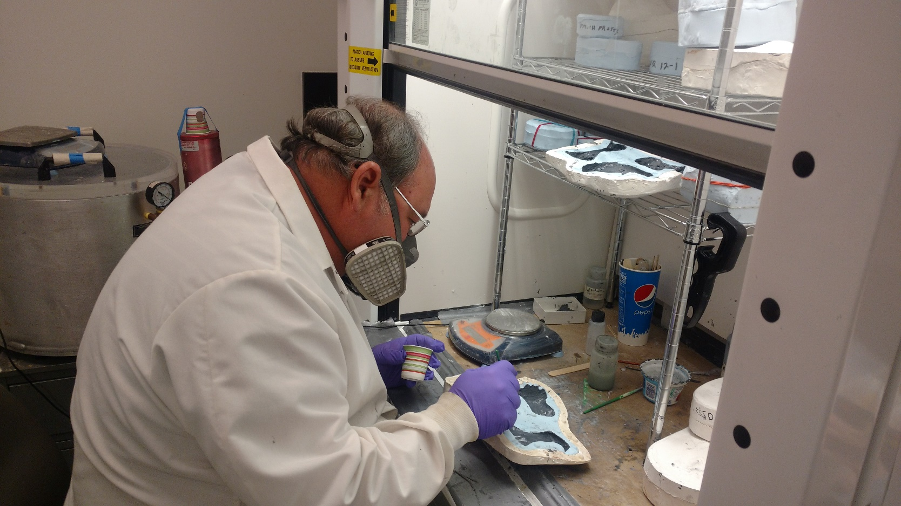
- Split mold and remove cast for postprocessing | Organic vapor from polyester | Organic vapor respirator, lab coat, nitrile gloves, fume hood

Volunteer preparators, NMMNHS

